KEYFRIEND Key Briefcase
Art.-no. 2695-9005

Part 1 of 2: Labeling area, exterior

 | Briefcase  No. 01 | Fire Department Any City  Key Briefcase  No. 01
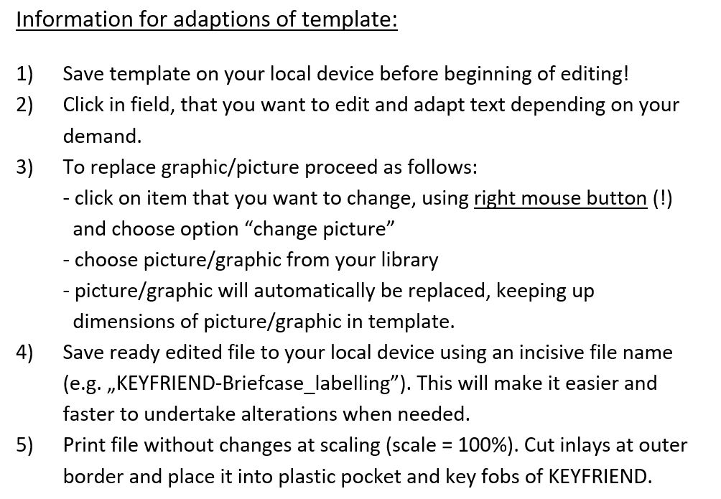

KEYFRIEND Key Briefcase
Art.-no. 2695-9005

Part 2 of 2: Key fobs
1 | 2 | 3 | 4 | 5
Hospital  „Any Name“  Any Street. 1-3  Building A | Town Hall  „Any City“  Any Street. 1-3  Car park | Theater  „Performance“  Theater Rd. 55  Dressing rooms | University  „Future graduates“  Study place 1  Hall of residence | Hospital  „Any Name“  Any Street. 1-3  Building A
6 | 7 | 8 | 9 | 10
Town Hall  „Any City“  Any Street. 1-3  Car park | Theater  „Performance“  Theater Rd. 55  Dressing rooms | University  „Future graduates“  Study place 1  Hall of residence | Hospital  „Any Name“  Any Street. 1-3  Building A | Town Hall  „Any City“  Any Street. 1-3  Car park

