KEYSAFE XL Key rack
Art.-Nr. 2689-9001

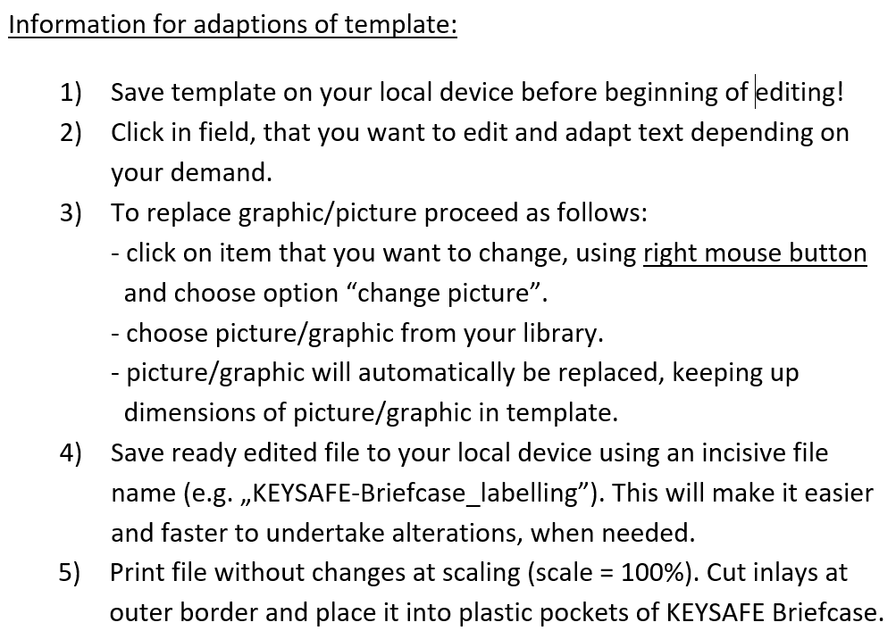
 | Key Rack  Nr. 001 | Fire Department Any City  Key Rack  Nr. 001

1 | 2 | 3 | 4 | 5 | 6 | 7
Hospital  „Any Name“  Any Street. 1-3  Building A | Hospital  „Any Name“  Any Street. 1-3  Building A | Hospital  „Any Name“  Any Street. 1-3  Building A | Hospital  „Any Name“  Any Street. 1-3  Building A | Hospital  „Any Name“  Any Street. 1-3  Building A | Hospital  „Any Name“  Any Street. 1-3  Building A | Hospital  „Any Name“  Any Street. 1-3  Building A
8 | 9 | 10 | 11 | 12 | 13 | 14
Hospital  „Any Name“  Any Street. 1-3  Building A | Hospital  „Any Name“  Any Street. 1-3  Building A | Hospital  „Any Name“  Any Street. 1-3  Building A | Hospital  „Any Name“  Any Street. 1-3  Building A | Hospital  „Any Name“  Any Street. 1-3  Building A | Hospital  „Any Name“  Any Street. 1-3  Building A | Hospital  „Any Name“  Any Street. 1-3  Building A
15 | 16 | 17 | 18 | 19 | 20 | 21
Hospital  „Any Name“  Any Street. 1-3  Building A | Hospital  „Any Name“  Any Street. 1-3  Building A | Hospital  „Any Name“  Any Street. 1-3  Building A | Hospital  „Any Name“  Any Street. 1-3  Building A | Hospital  „Any Name“  Any Street. 1-3  Building A | Hospital  „Any Name“  Any Street. 1-3  Building A | Hospital  „Any Name“  Any Street. 1-3  Building A
22 | 23 | 24 | 25 | 26 | 27 | 28
Hospital  „Any Name“  Any Street. 1-3  Building A | Hospital  „Any Name“  Any Street. 1-3  Building A | Hospital  „Any Name“  Any Street. 1-3  Building A | Hospital  „Any Name“  Any Street. 1-3  Building A | Hospital  „Any Name“  Any Street. 1-3  Building A | Hospital  „Any Name“  Any Street. 1-3  Building A | Hospital  „Any Name“  Any Street. 1-3  Building A

